Nom : ……………………………. Date : …………………………….
CP

Lecture
Fiche
L23

Mots fléchés [B] an am



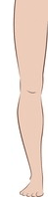
 |  |  |  | 
 |  |  |  |  | 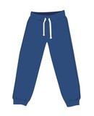 |  |  |  | 
 | 
 |  | 

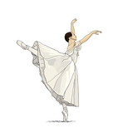
http://www.i-profs.fr

Nom : ……………………………. Date : …………………………….
CP

Lecture
Fiche
L23

Mots fléchés [B] an am

tambour – panda – pantalon – éléphant – triangle – lampe – jambe - danseuse
http://www.i-profs.fr

Nom : ……………………………. Date : …………………………….
CP

Lecture
Fiche
L23

Mots fléchés [B] an am

 |  |  |  |  |  |  |  | j
 |  |  | é | l | é | p | h | a | n | t
 |  |  |  | a |  | a |  | m |  | r
 |  |  |  | m |  | n |  | b |  | i
 |  |  |  | p |  | t |  | e |  | a
 |  |  |  | e |  | a |  |  |  | n
 |  |  | p |  |  | l |  |  |  | g
 |  | t | a | m | b | o | u | r |  | l
 |  |  | n |  |  | n |  |  |  | e
 |  |  | d
 |  | d | a | n | s | e | u | s | e
http://www.i-profs.fr

